**Vendor Performance Analysis**

**Business problem**

In retail and wholesale, profitability heavily depends on strong control of sales and inventory. Companies risk losses if:

* Pricing strategies are misaligned
* Inventory turnover is weak
* Too much reliance is placed on a handful of suppliers

**Objectives**

This project aims to:

* Pinpoint brands that underperform and may benefit from promotional or pricing changes
* Highlight the vendors driving the largest share of revenue and profit
* Measure how bulk purchasing influences unit costs
* Assess inventory turnover to lower holding costs and boost efficiency
* Compare profitability patterns between top-performing and weaker vendors

**Exploratory Data Analysis (EDA)**

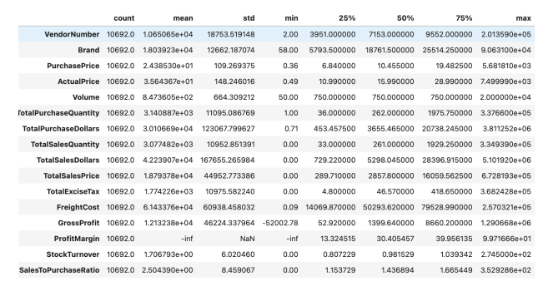

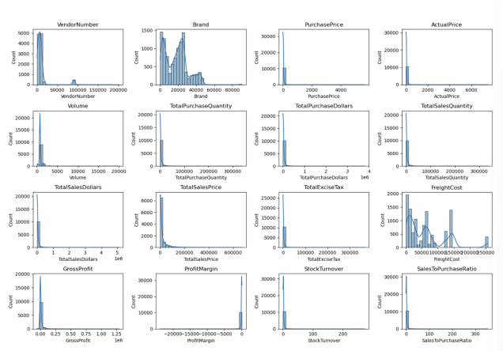

**Negative & Zero Values**

* **Gross Profit:** Reached as low as -52,002.78, signaling possible losses from over-discounting or below-cost sales.
* **Profit Margin:** Dropped to -∞ in some cases, showing revenue didn’t cover costs.
* **Zero Sales:** Some items were bought but never sold → potential dead stock.

**Outliers**

* **Price Points:** Maximum purchase/actual prices (5,681.81 & 7,499.99) far above averages (24.39 & 35.64), suggesting premium items exist.
* **Freight Costs:** Extremely variable (0.09 – 257,032.07), pointing to inconsistent shipping practices.
* **Stock Turnover:** Ranged from 0 – 274.5. Some products never sold; others cycled rapidly.

**Data Cleaning**

To enhance insights, removed records where:

* Gross Profit ≤ 0
* Profit Margin ≤ 0
* Sales Quantity = 0

**Correlation Findings**

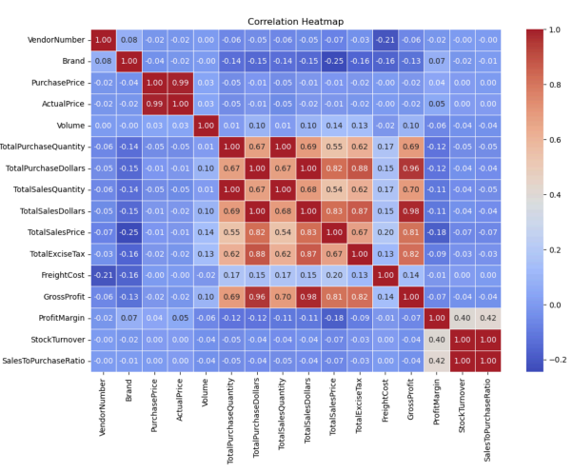

* **Purchase Price vs Sales/Profit:** Virtually no relationship (≈ -0.01) → price doesn’t drive revenue directly.
* **Purchase Quantity vs Sales Quantity:** Strong link (0.999) → purchased stock is moving.
* **Profit Margin vs Sales Price:** Negative relationship (-0.179) → raising prices may hurt margins.
* **Turnover vs Profitability:** Weak negative link → quick stock movement doesn’t guarantee higher profit.

**Research Questions & Answers**

1. **Which brands should be promoted or re-priced?**

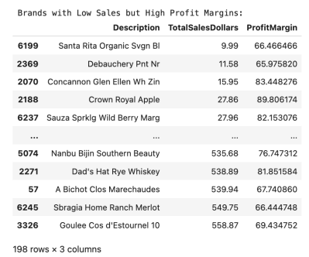

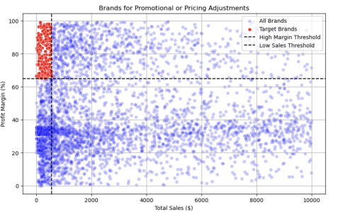

* + 198 brands with low sales but solid margins could gain from better marketing or pricing shifts.

1. **Which vendors dominate purchases and sales?**
   * Top 10 vendors supply **65.7% of all purchases**, creating dependency risk.

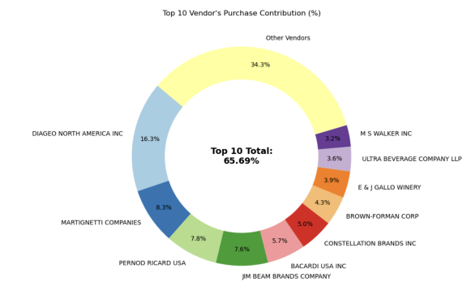

1. **Does bulk buying reduce costs?**
   * Yes: Large orders lower unit cost by **72%** ($10.78 per unit).
2. **What’s the cost of slow-moving stock?**
   * Capital tied up in unsold inventory = **$2.71M**.

1. **How do margins differ across vendor groups?**
   * **Top Vendors:** Avg margin = 31.17%
   * **Low Vendors:** Avg margin = 41.55%

* + Suggests smaller vendors maintain higher prices but struggle with sales volume.

1. **Are these margin differences significant?**
   * Hypothesis testing rejects the null → the groups follow different profit models.

**Recommendations**

* Adjust pricing for brands with high margins but weak sales.
* Broaden the vendor base to reduce overreliance.
* Use bulk purchases strategically to balance cost savings and inventory risk.
* Clear slow stock through discounts or smaller restock orders.
* Strengthen promotion and distribution for vendors with limited reach.